***Report of Lab1 Mike Li***

**P1.1**

My threshold is 220. The output image is 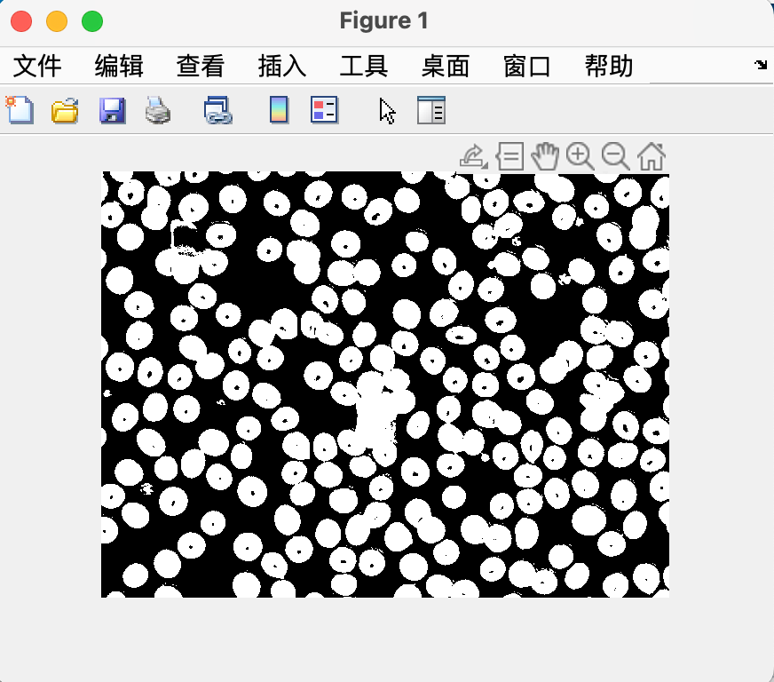

P1.2

My first threshold is 80 and my second threshold is 180.

outcome:

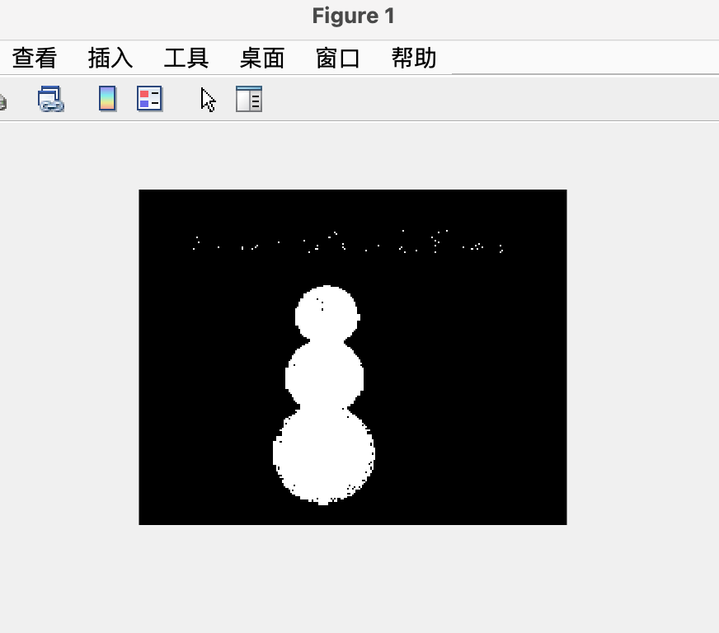

P2.1

I tried increase/decrase the light intensity by 10%, 25, and 50.

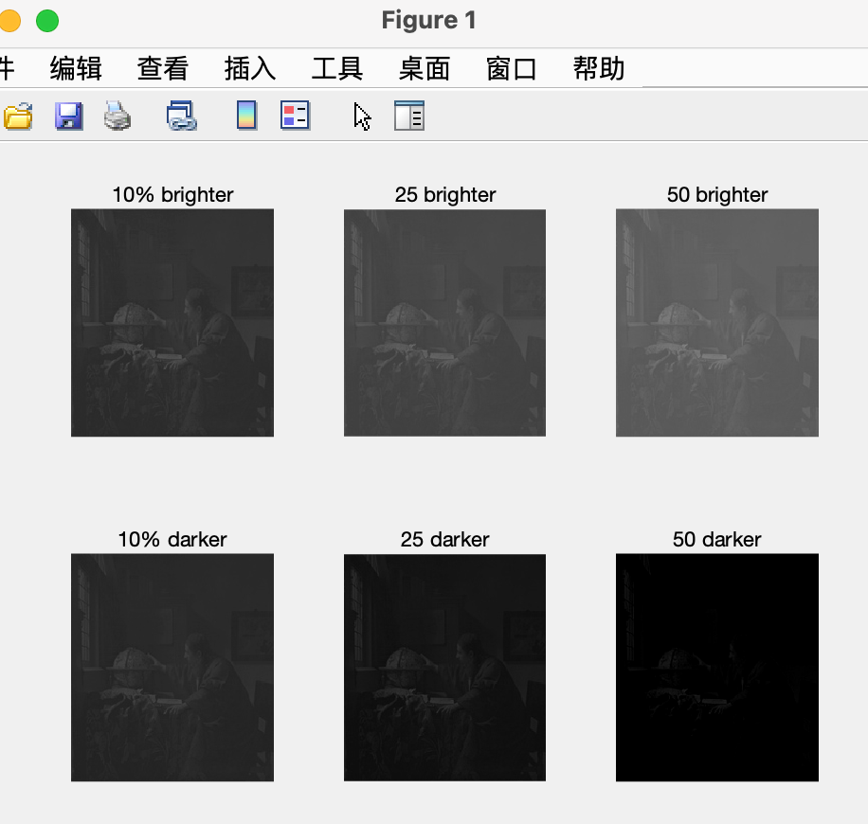

P2.2

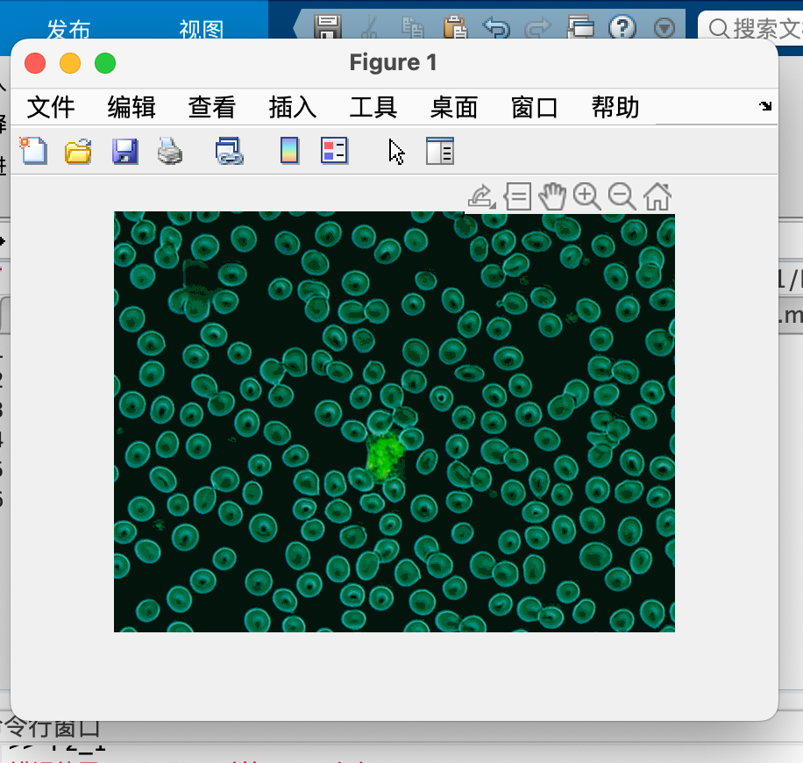

P3

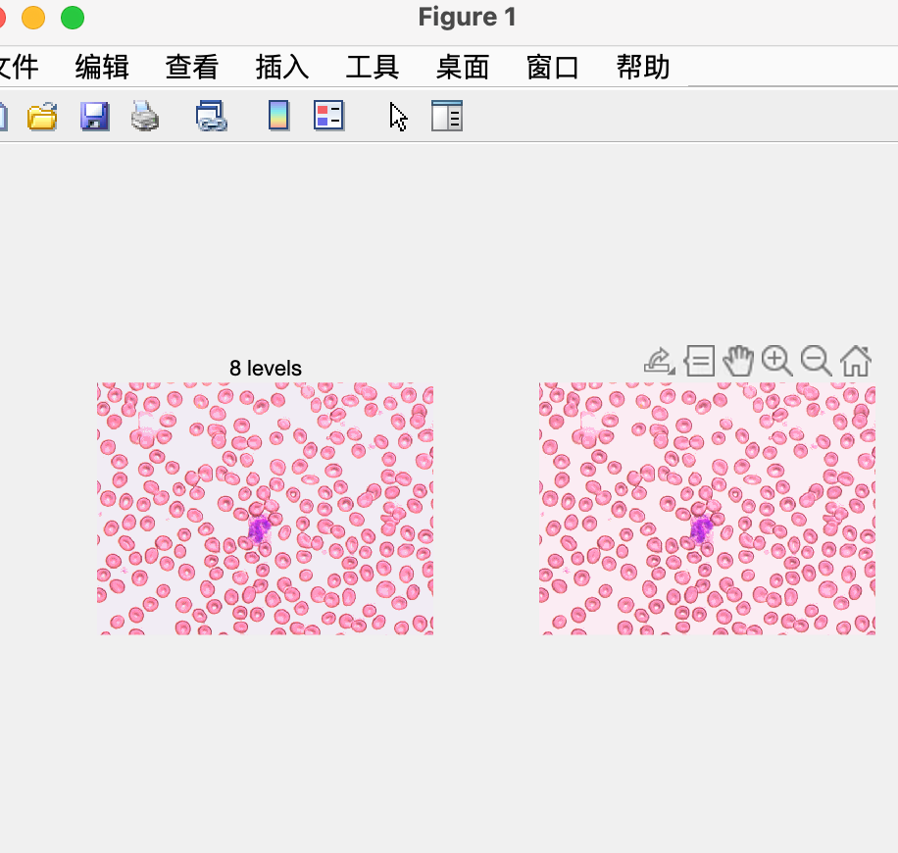

P4

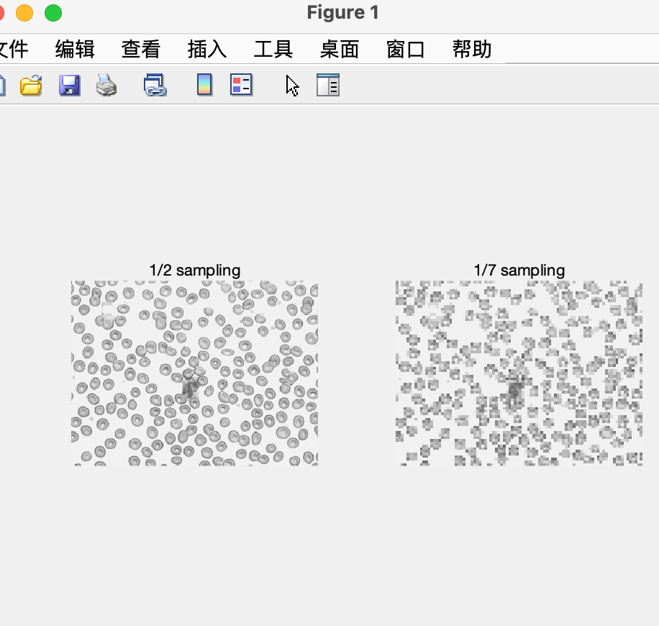

P5.1

mean img:

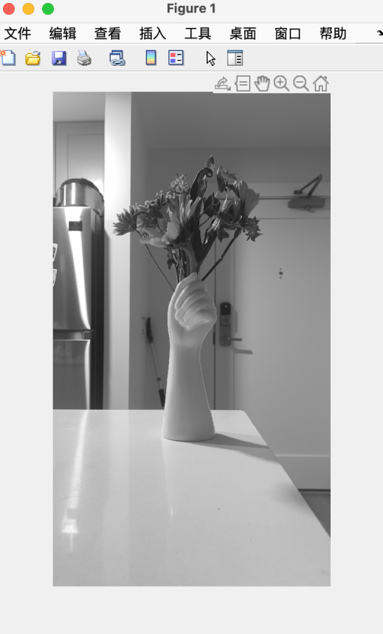

std img:

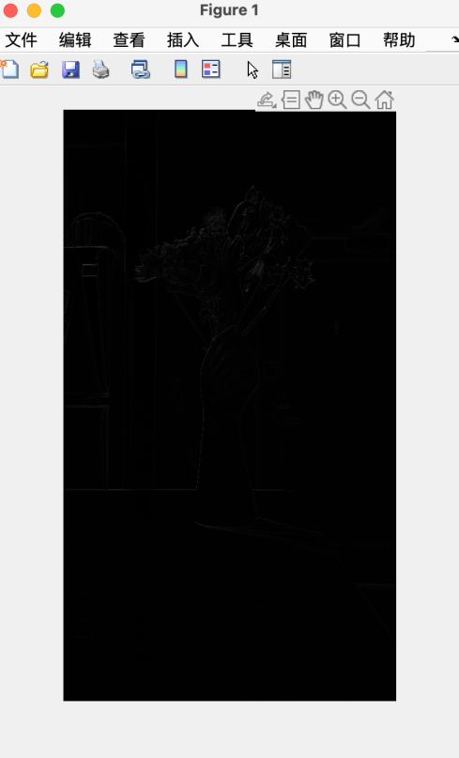

P5.2

The maximum difference is 1.3791e+05

P5.3

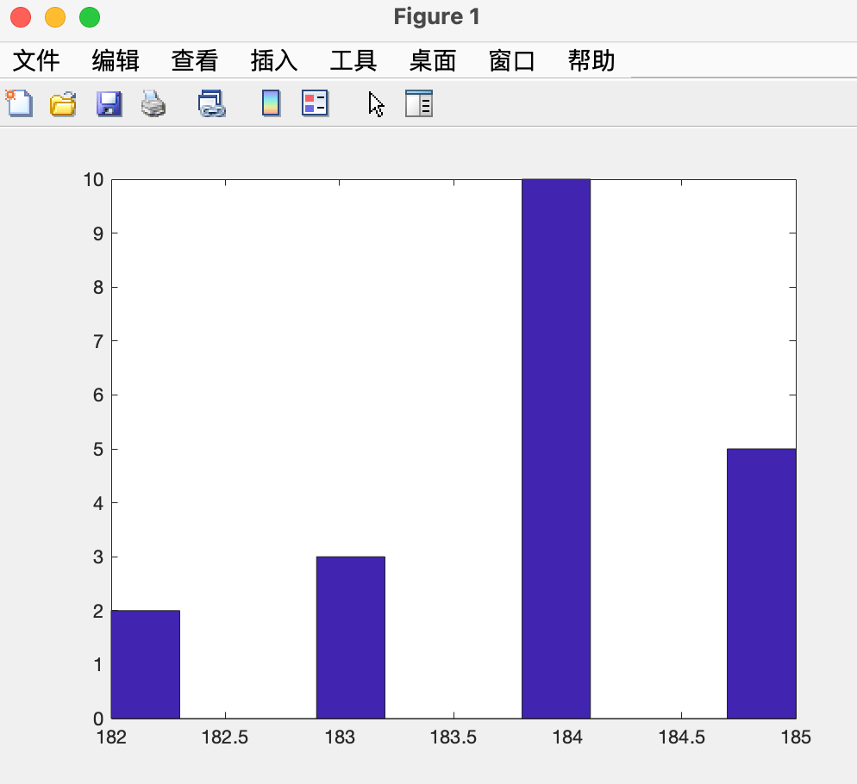

Here is the （1，1） pixel histogram for these 20 diagrams.